May the 4th Be With You Collage
An Art Lesson for Grades 3, 4 and 5 (Week of May 4th)

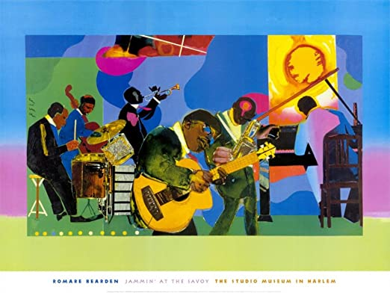
A collage is a piece of art made by sticking various different materials such as photographs and pieces of paper or fabric on to a backing surface. Romare Bearden is a well-known collage artist with a North Carolina connection. He was born in Charlotte, NC on September 2nd, 1911 and passed away on March 12th, 1988. He created the artwork seen above in 1981 using a variety of colored pieces of paper. Bearden often created collage artworks showing musical performances and scenes from everyday life.
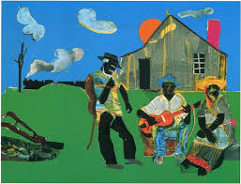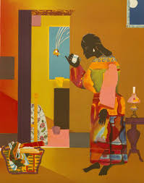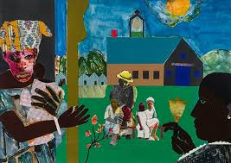
At times, he would cut shapes from colored pieces of paper that he painted or added designs to in order to make his collage artworks. Sometimes, he would even use pictures cut from magazines and newspapers.
Romare Bearden isn’t the only famous artist to use the artform of collage. Take a look at some other examples of collage made by other artists:
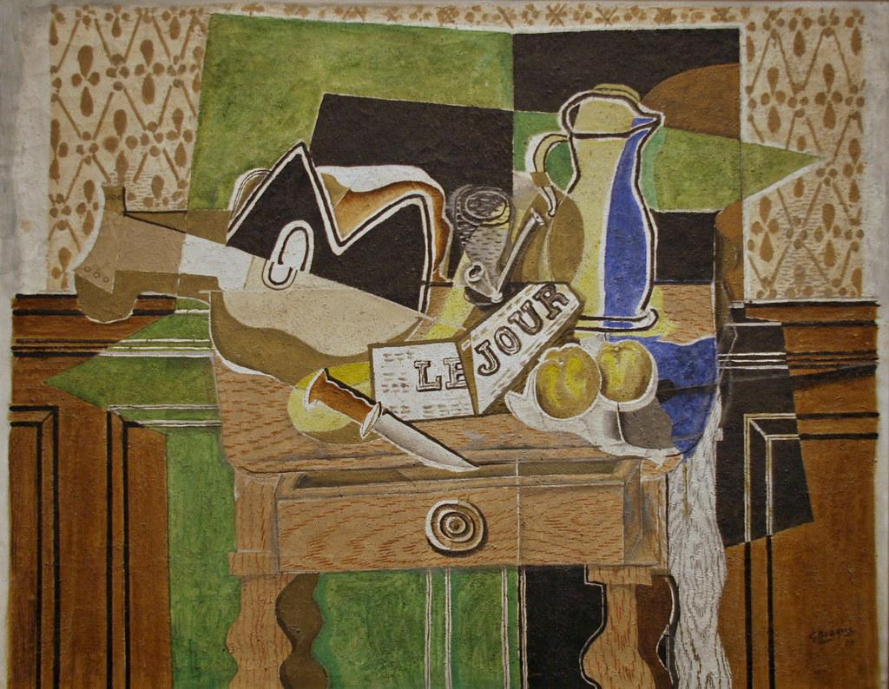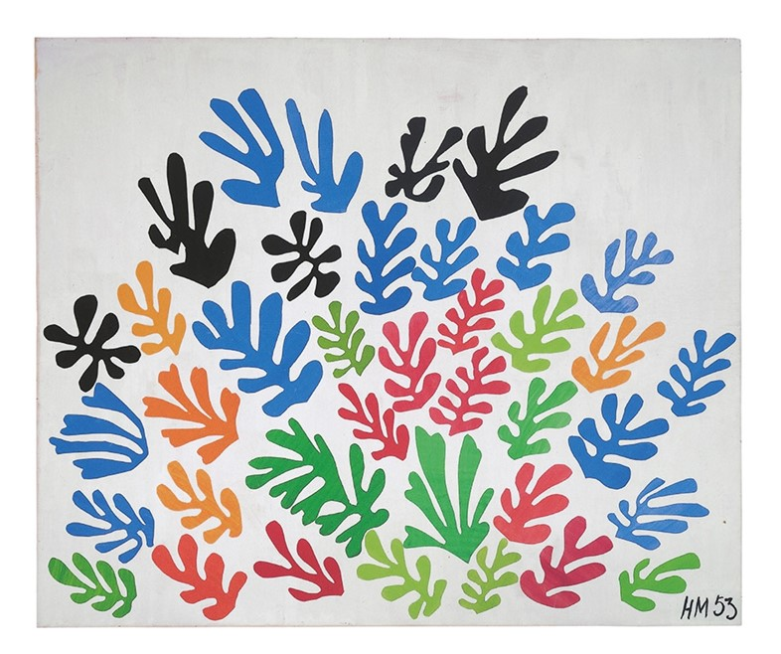
“Still life: Le Jour” by Georges Braque, 1929 “The Sheaf” by Henri Matisse, 1953

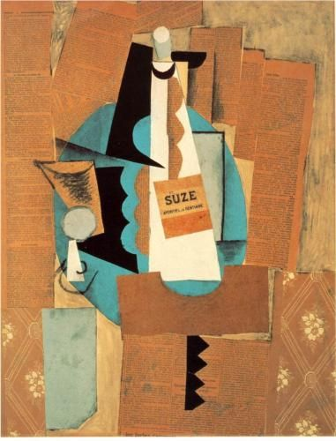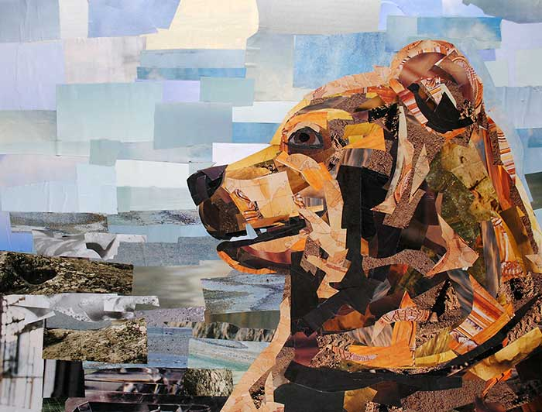
“Glass & Bottle of Suze” by Picasso, 1912 “Brown Bear” by Megan Coyle, 2012

Create your own collage inspired by May the 4th (as in “May the 4th be with You”, the unofficial Star Wars Day).

You will be creating a collage artwork of “Baby Yoda.” If you are unfamiliar with this Star Wars character, there are lots of images found online that can help you.

For this activity you will need a variety of colored pieces of paper, pencil, glue, scissors, black marker.

Be sure to follow the steps below:

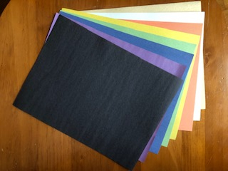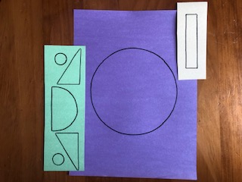
Use a variety of colored paper. Draw the basic shapes for Yoda and his
Hover crib.

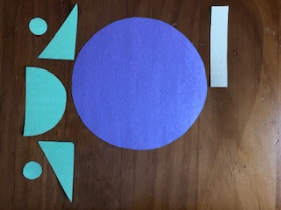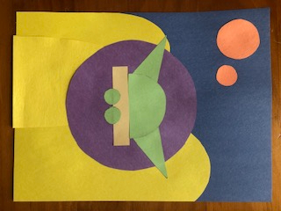
Carefully cut out drawn shapes. Create a background of your choosing
using other colored pieces of paper.
Then arrange and glue all shapes.

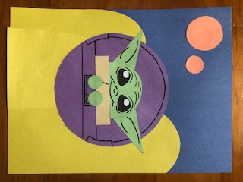
Using black marker, add many details to Yoda
and his hover crib.

Things to think about:
- You can use your own colors of paper but Yoda should be green.
- If you don’t have a variety of colored papers to use you can color plain white paper with crayon, marker or colored pencil.
- Get creative and use different objects to trace the shapes you need like the rectangle, semi-circle, triangles and circles of varying sizes.
- Carefully draw your details with pencil first. Then, when you are happy with how they look, trace over your lines with black marker.
- The look of the background is up to you. Remember though, this is a “Star Wars world.” Fill your background with imaginative hills, mountains, trees, rock formations, multiple suns/stars/planets, etc...

Notable quotes from Master Yoda:
“Do or do not. There is no try.”
“Control, control. You must learn control!”
“Patience you must have.”
“The greatest teacher, failure is.”
“Judge me by my size, do you?”
“Pass on what you have learned.”

May the 4th be with you artists!

