Rotational Symmetry
An Art Lesson for Kindergarten, 1st and 2nd Grade (Week of April 27)
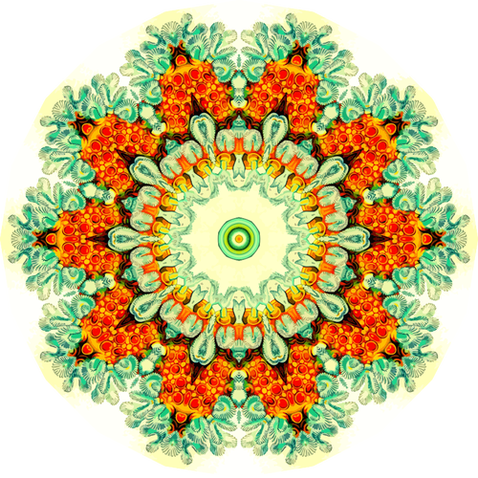
Although it sounds complicated, rotational symmetry is really rather simple to understand. It means that a shape, line or design goes around and around in a circle and always appears the same.
There are lots of examples found in nature that represent this idea of rotational symmetry. Check some of them out below:

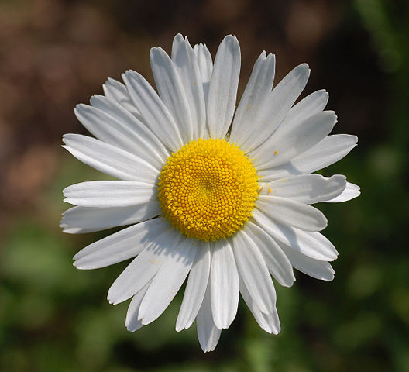

Artists use rotational symmetry in their artworks often. Look at these artworks by different artists and notice how lines, shapes and designs repeat all around:
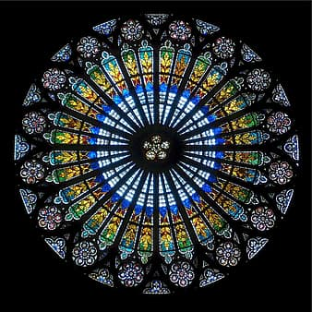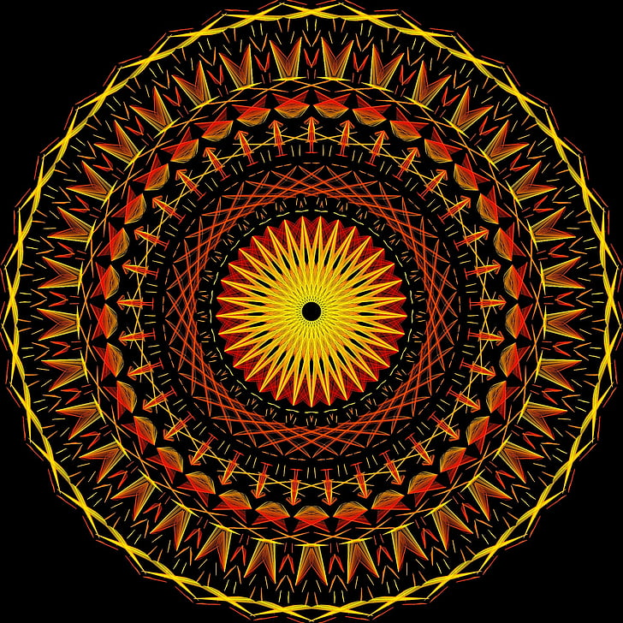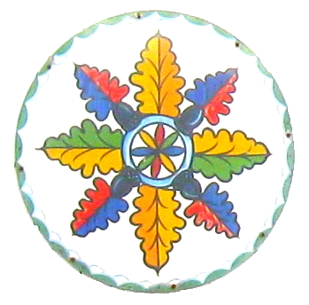
Rose Window, stained glass Mandala Design, India Dutch Hex Design commonly
Strasbourg Cathedral found on Pennsylvania barns

Using Rotational Symmetry with your name

For this artwork you will need a plain piece of white paper, a small bowl or something else round to trace, pencil, eraser, black marker, crayons or colored pencil.

Step 1: Using a bowl or something else round, trace a large circle on paper.
Step 2: Carefully cut out the circle.
Step 3: Fold the circle in half once, twice and then a third time. Once you
open the circle, you will see 8 “pie slices.”
Step 4: Use your pencil to write your name within each “slice” making sure
your letters touch the top and bottom of each “slice.”
Step 5: Trace over your letters with black marker.
Step 6: Add a variety of color to your design filling in all white spaces.

Look at step examples below:
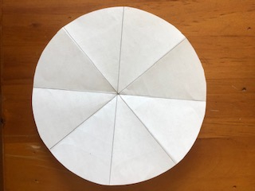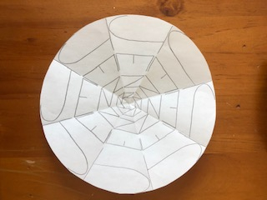
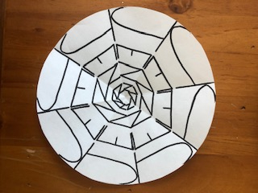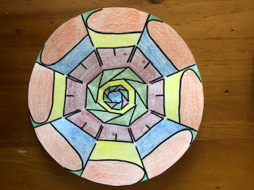
****Note the name “Jenn” is repeated throughout the artwork.****

Things to think about when making your artwork:
- Cut out circle slowly.
- If you are having trouble folding, ask an adult to help.
- When writing your name, make your letters look the same in each
pie slice. Will you use all capital letters or some lowercase letters?
- Trace your letters slowly with black marker.
- Use lots of different colors in between and around your letters. Think
about how the colors should look the same around and around too.

