Seaside Sand Art
An Art Lesson for Kindergarten, 1st and 2nd Grade (Week of April 20th)

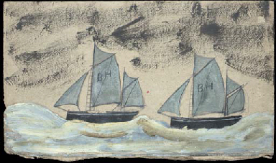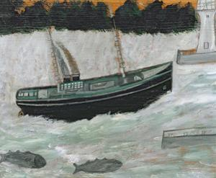
Alfred Wallis “Two sailboats with BH on the Sails” and “Lighthouse with Trawler and Fish”

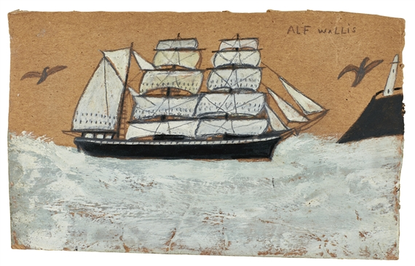
Alfred Wallis “Barque and Lighthouse”
Alfred Wallis was an artist, but to his friends and family he was a fisherman. This was how he made his money. Wallis was born in Penzance in Cornwall, UK. Living on the coast, there was a lot of opportunity to fish. At one point, he even became a sailor. The sea was very important to him. That’s why so many of his paintings are of the sea and the coast. This is what Wallis knew and grew up around.
Soon, people outside of Cornwall knew Wallis as a painter, rather than as a fisherman. He became a small celebrity in the 1930s. Unfortunately, Wallis could not sell many of his paintings and he lived with little money for most of his life.
Wallis never had an art lesson. At the time, art was never taught in schools. Wallis taught himself how to paint. Even without any training, he just did it, because he wanted to. This is why his paintings are called naÏve. This means that he did it without knowing any of the technical methods of how to paint. He simply put his paintbrush on the canvas and did what he thought would look good. Some of his paintings may look a little odd, but that's what makes them special.

Alfred Wallis mainly used paint to make his seaside artworks. However, you’re going to make some art using sand from the beach. Take a look at some of Wallis’ art. What do you want to include in your picture? How about a boat, waves, a lighthouse, a bridge, a dock, the shore, etc..

For this activity you will need a pencil, white liquid glue, a spoon, 2 colored pieces of paper (one larger than the other) and sand (sugar, salt or glitter can be used if you don’t have sand).

Follow the steps below:
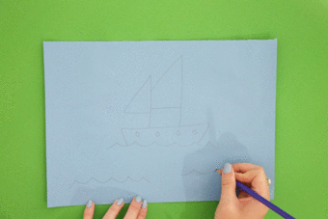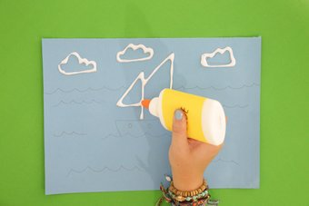
Draw your image with a pencil on smaller paper. Trace over all pencil lines with glue.

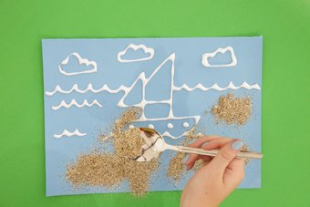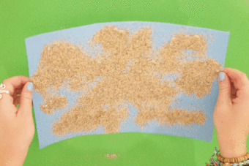
Using a spoon, sprinkle sand covering glue lines. Lift up paper and gently shake off excess sand.
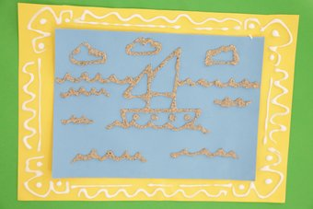
Rest artwork on larger paper and add glue designs. Remove artwork and sprinkle sand on glue lines.

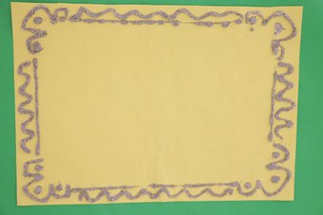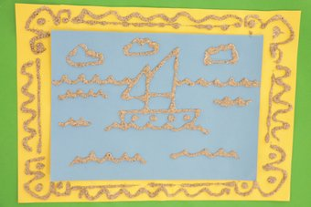
Lift up larger paper and gently shake off excess sand. Center and glue artwork on the larger paper.

Things to think about when making your artwork:
- Choose 2 different colors of paper that work well with one another.
- Draw lots of objects filling up the paper.
- Draw large objects with few details.
- Move the glue bottle slowly (an adult can help you).
- Shake off extra sand outside or over a trash can.
- Allow both papers to fully dry before gluing them together.

