Still Life About You
An art lesson for Kindergarten, 1st and 2nd Grade.
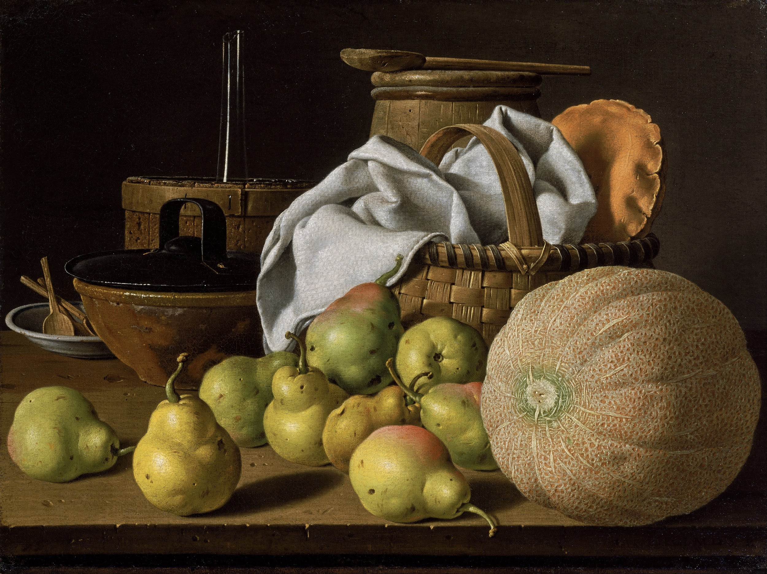
“Still Life with Melon and Pears” Luis Mendez, Oil paint on canvas, 1772

A still life is a work of art showing inanimate objects (things that don’t move) carefully arranged / set up on a table or stand. Objects can be a mix of natural (food, flowers, seashells,...) and man-made (books, vases, drinking glasses, …) items. Oftentimes, objects in a still life tell about an artist’s ideas and interests or tell a story.
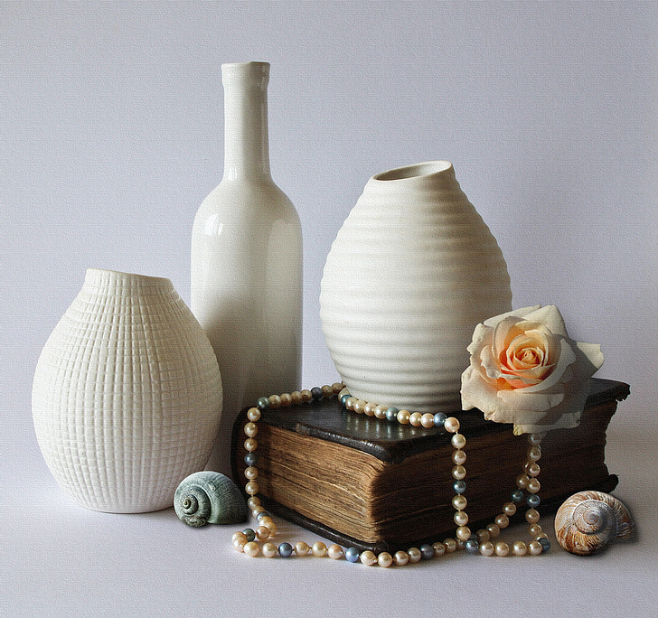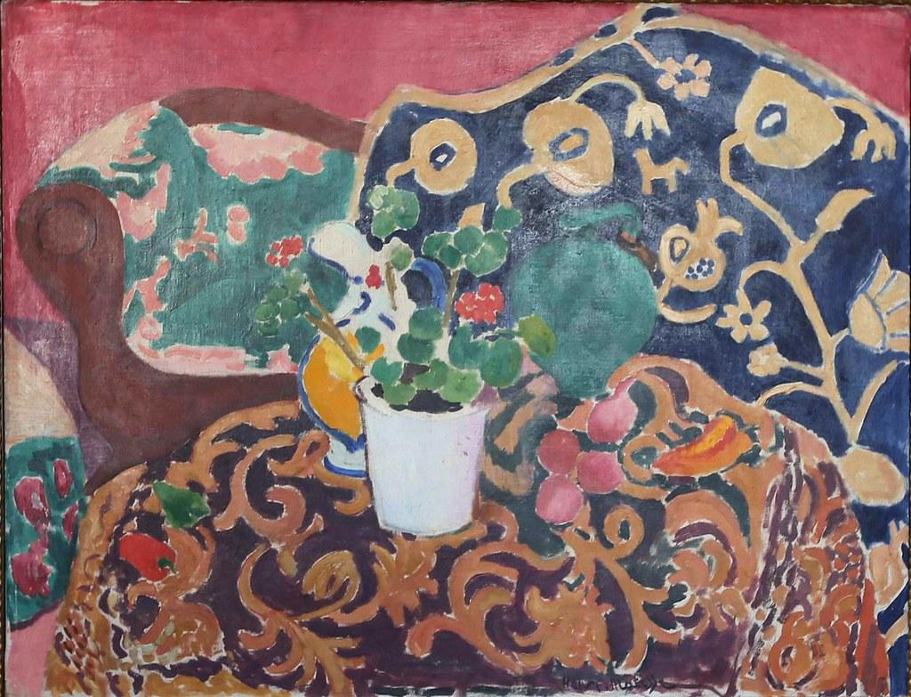
Sometimes a still life can look very realistic, like this one on the left. Other times it can look more “cartoon-like” like the one on the right.
Make your own Still Life all about You

Choose lots of items from your home that tell who you are and what you like. Think about your hobbies, your toys, your favorite foods, the sports or games you like to play, etc… .Carefully set up these objects on a sturdy table or stand and draw your still life.

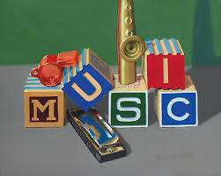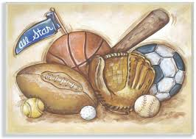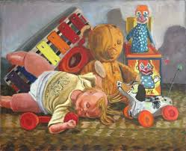
Check out some of these still life ideas.

For this activity you may use any size white paper, pencil, crayon, marker or colored pencil.

Things to think about when making your own still life:
- Choose 5-8 items and be sure to show variety.
- Set up items on a flat surface.
- Show overlapping (one object slightly in front or behind another).
- Will you have a tablecloth under your items?
- What might you show in the background (behind your still life)?
- To show contrast, will the objects be brightly colored with a darker background or will you do the opposite?
- Will you add shading to your items or show shadows?

Related Art Vocabulary
Arrange, Overlap, Shading, Variety, Background, Contrast

