“Make Pop Art Like Andy Warhol”
An art lesson for grades 3, 4 and 5 (Week of April 13th).
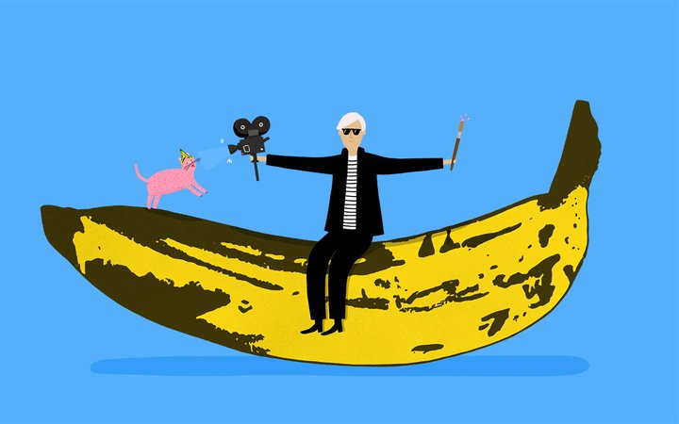
Illustration by Rose Blake from “Meet the Artist: Andy Warhol.”

Andy Warhol (1928-1987) was an American artist, film director and producer who was a leading figure in the visual art movement known as Pop Art. He took what we thought we knew about art and turned it on it’s head. His work makes us ask questions like:

- What is art?
- Who can be an artist?

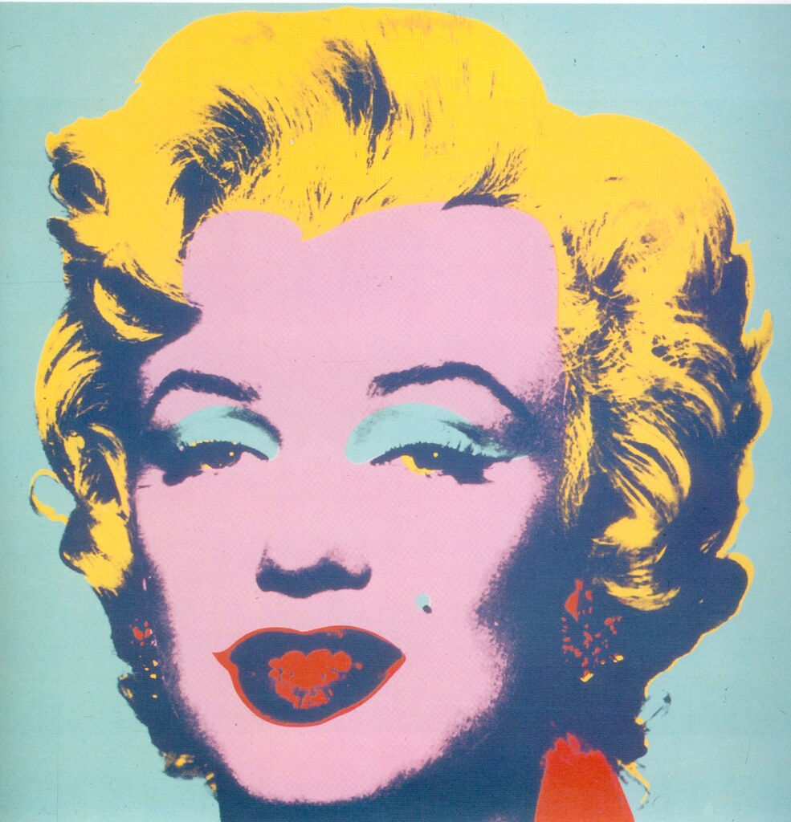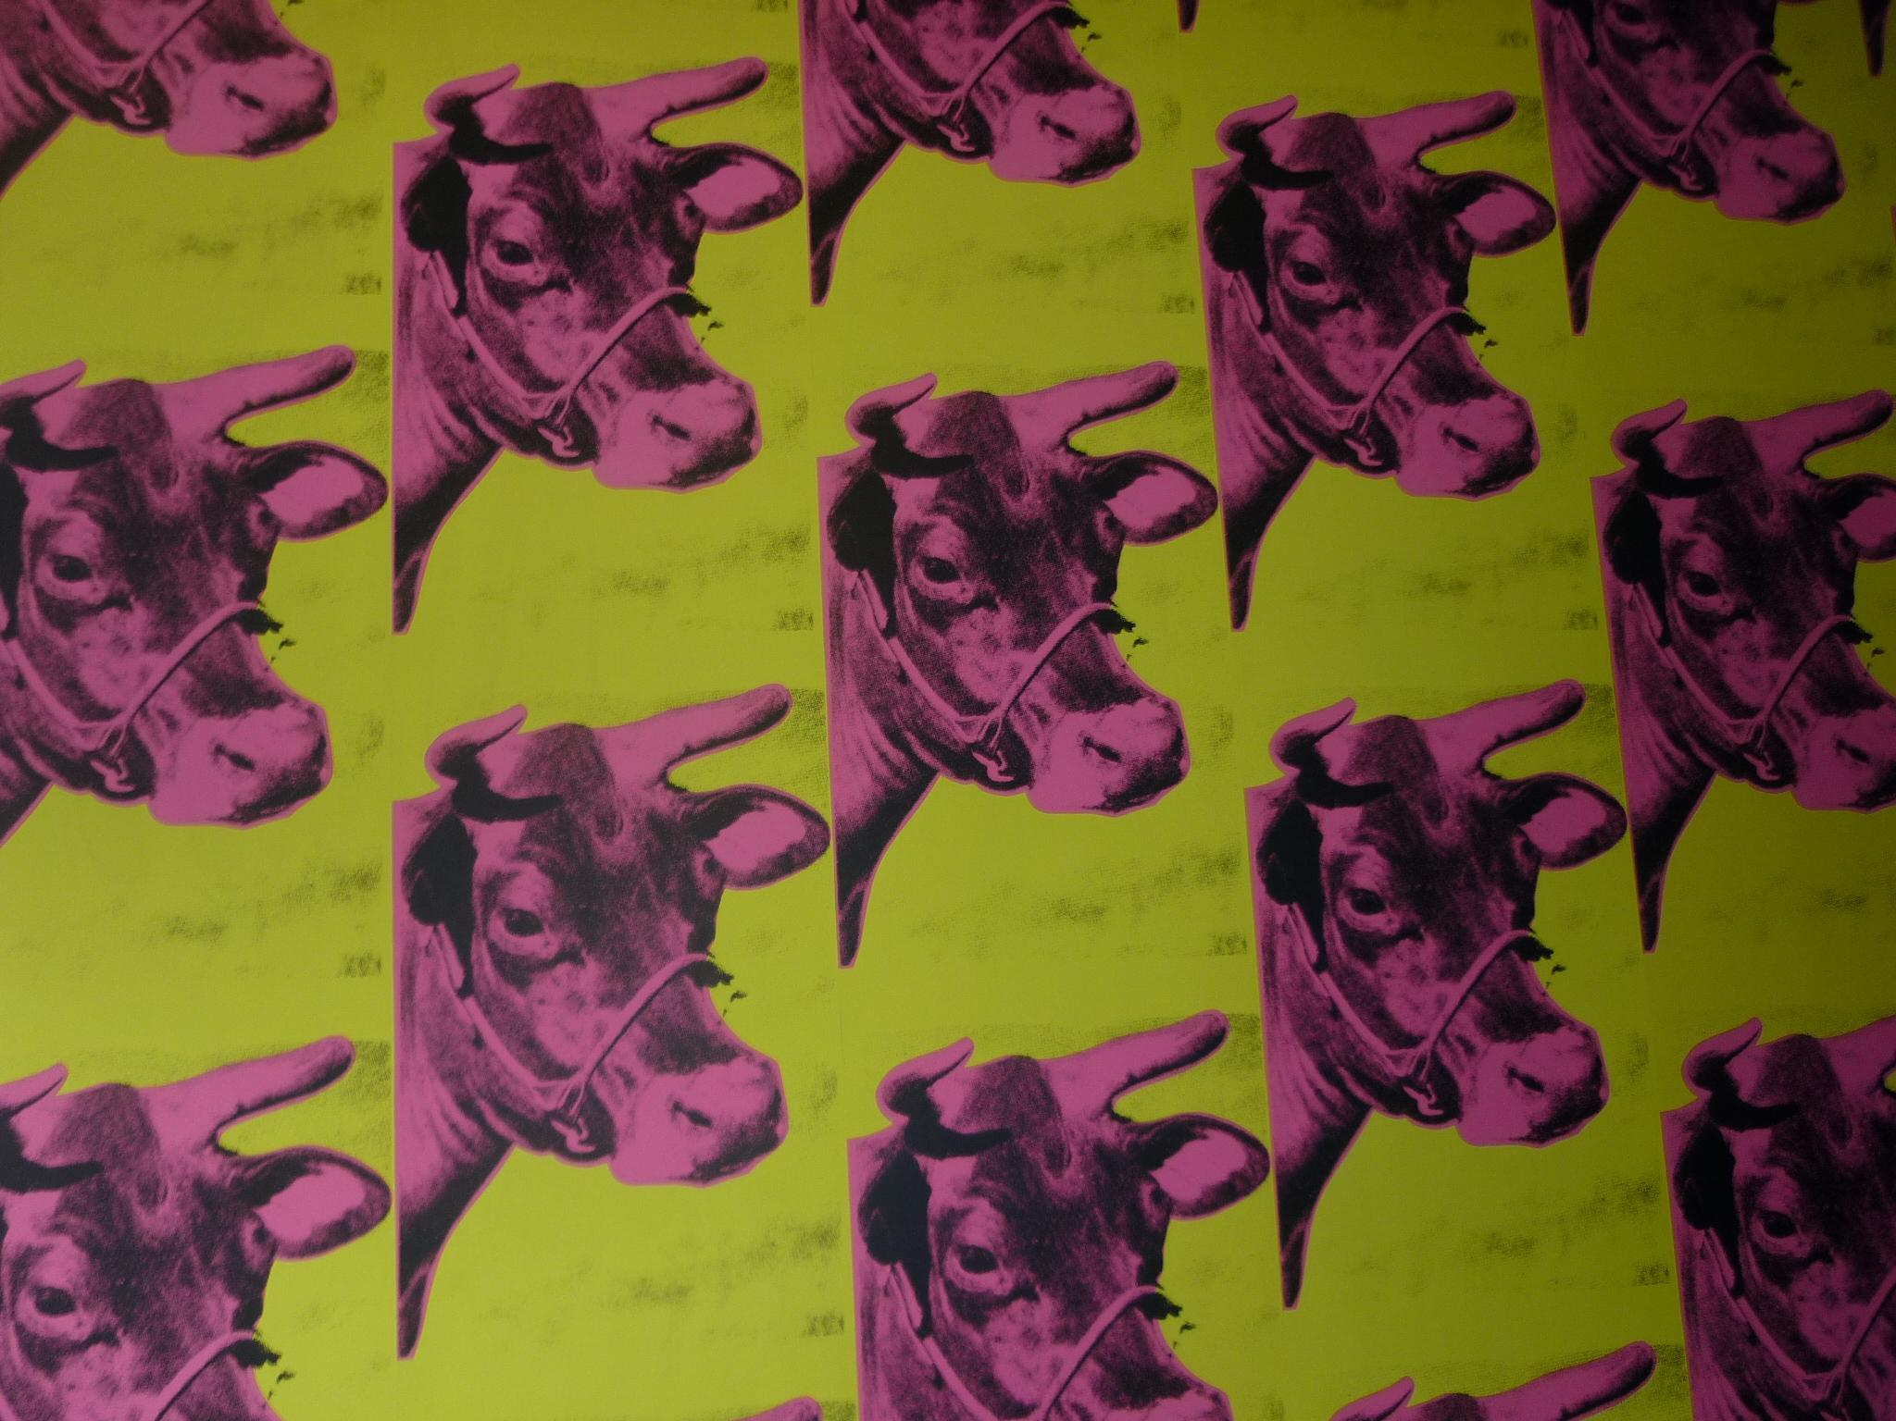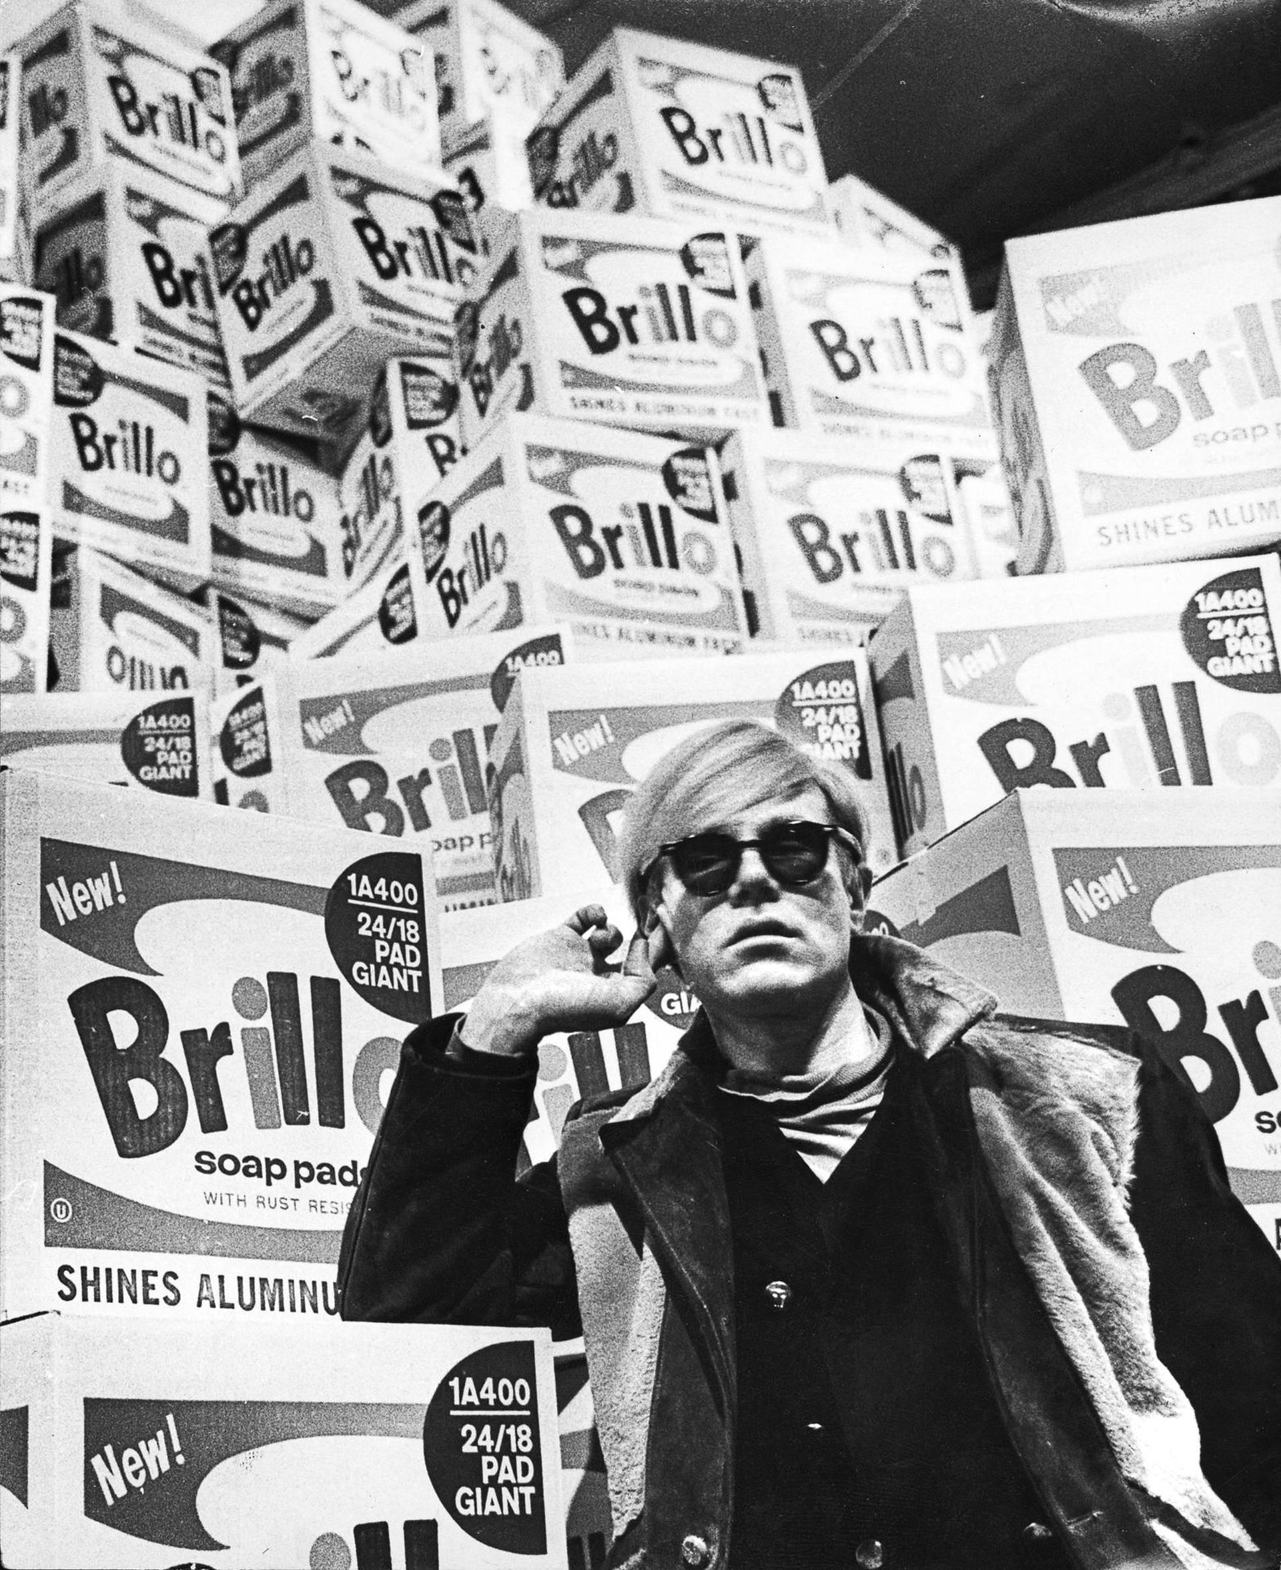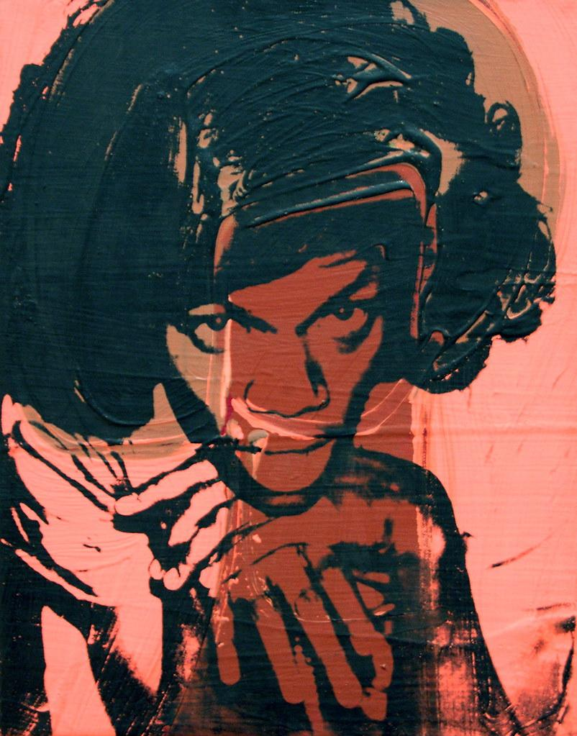
Pop artists felt that art should reflect modern life so they made art inspired by the world around them - from movies, advertising and pop music to comic books and even product packaging.
Warhol was famous for exploring everyday objects in his work, using brands such as Coca-Cola, Brillo and Campbell’s Soup. He liked the idea of taking ordinary things and turning them into works of art.

Design your Own Soup Can
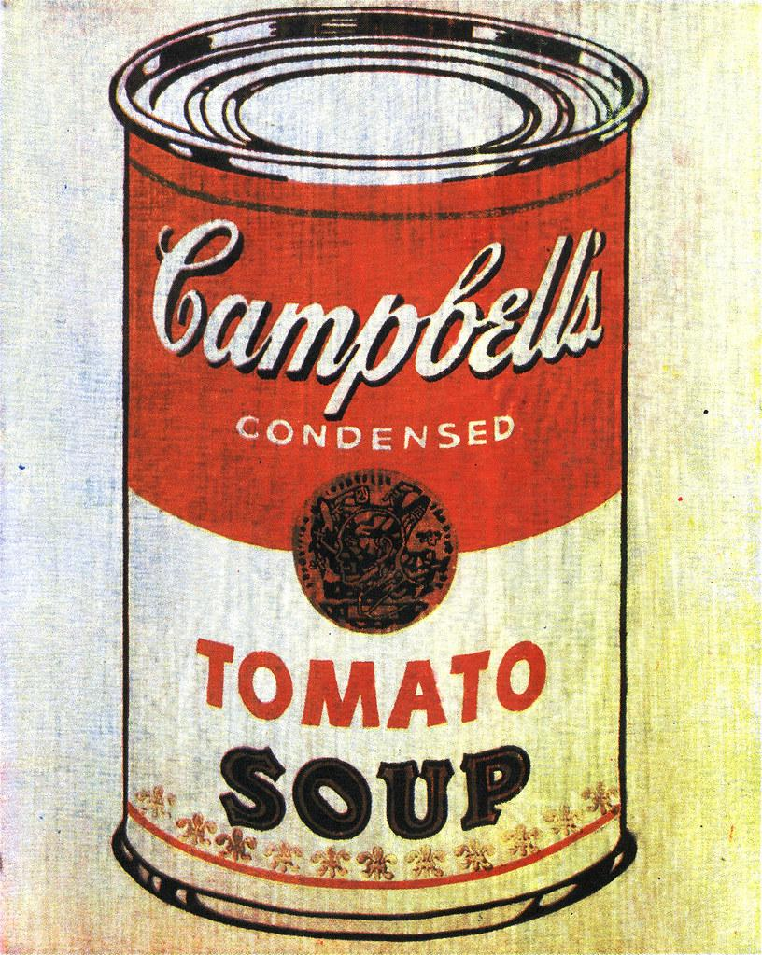
Image from “32 Campbell Soup Cans” Andy Warhol, 1962, Paint on Canvas.

For this activity you may use any size white paper, pencil, crayon, marker or colored pencil.

Things to consider when designing your own soup can:
- Will this be a real soup flavor or an imaginary one?
- What ingredients will go in your soup?
- What will it be called?
- How will the lettering look on the label?
- Should the can be colored bright and bold or cool and dark?
- How would it look on a shelf in the grocery store?

Check out some of the other Pop Art food and drink Warhol created.

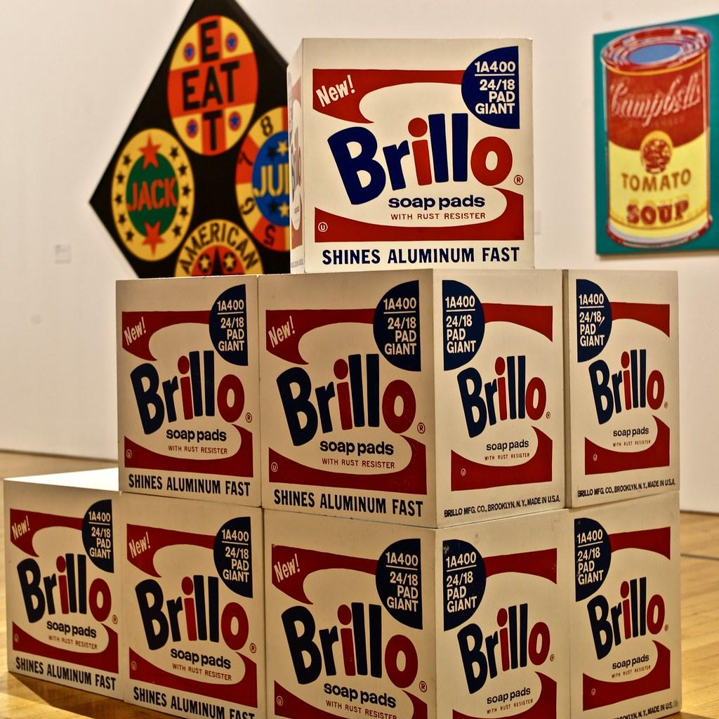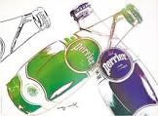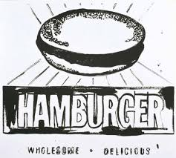

Quotes from Andy Warhol:

“Art is what you can get away with.”
“Everyone will be famous for 15 minutes.”
“There is beauty in everything, just not everybody sees it.”
“They always say time changes things, but you actually have to change them yourself.”

