Zentangles
An Art Lesson for Grades 3, 4 and 5 (Week of April 27th)
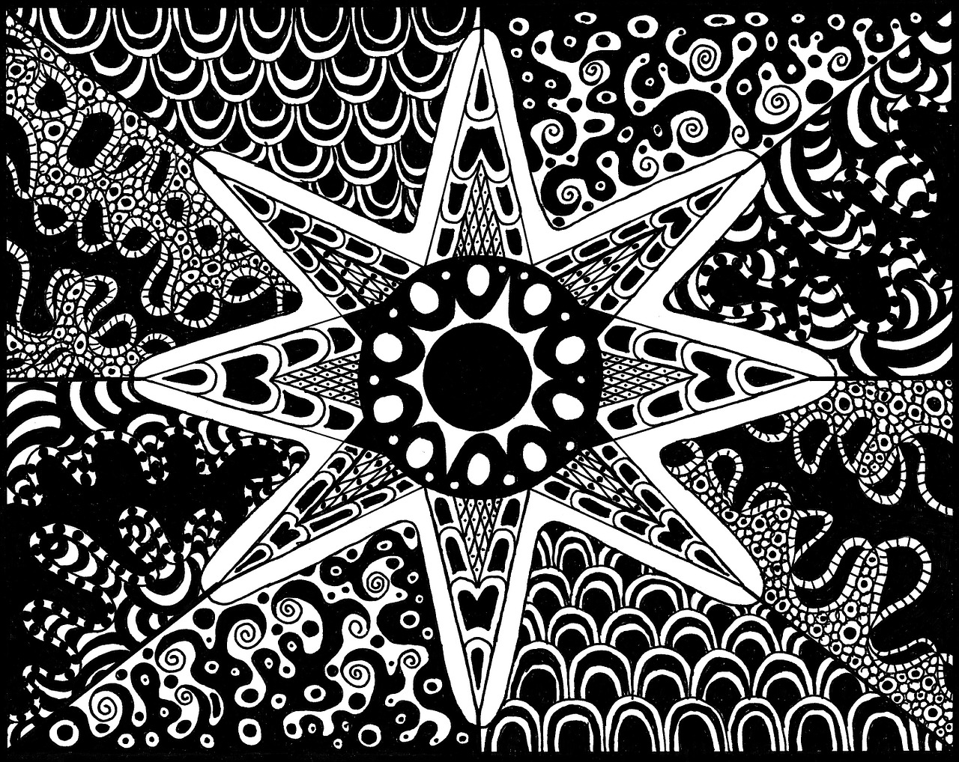

Zentangle is a form of artistic meditation through very careful linework. It results in abstract drawings made of patterns (lines, shapes, designs that repeat). Zentangles do not contain any recognizable objects and there is no
“right side up.” Zentangle art requires great focus and concentration and is different compared to doodling. Doodling can be sloppy and is something a person can do randomly while their thoughts are occupied with something else.

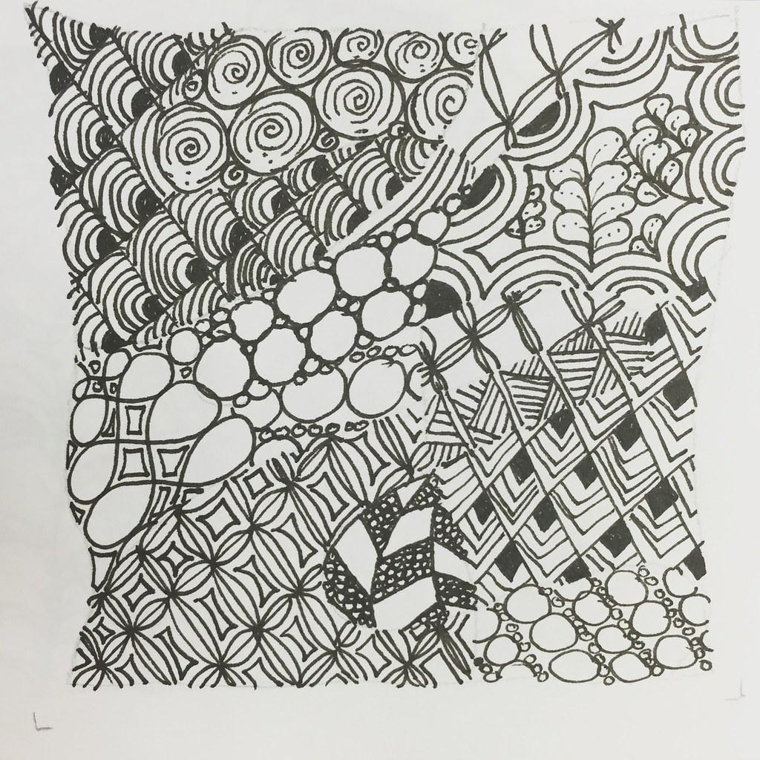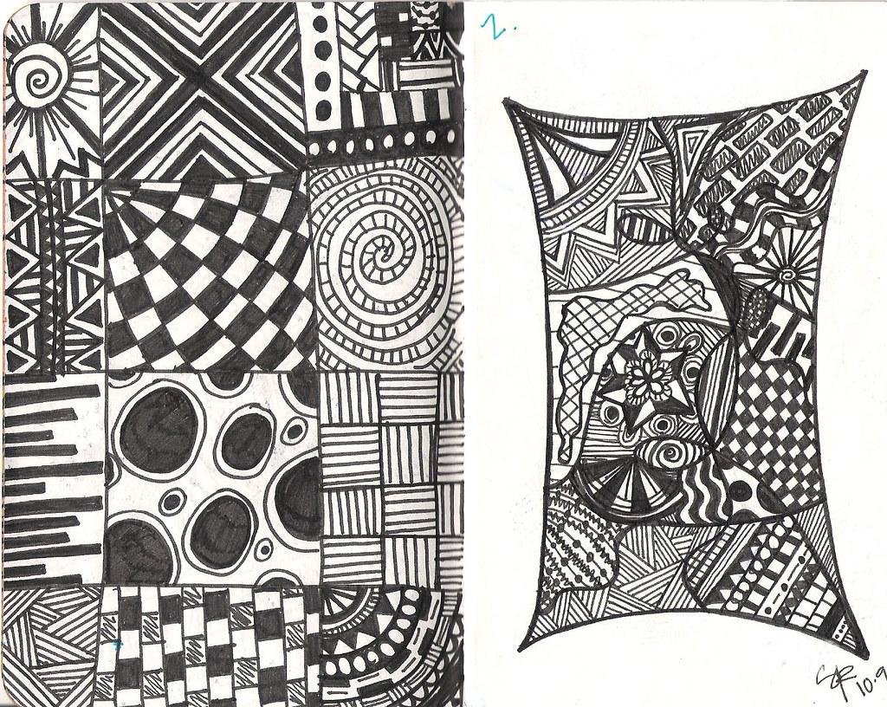
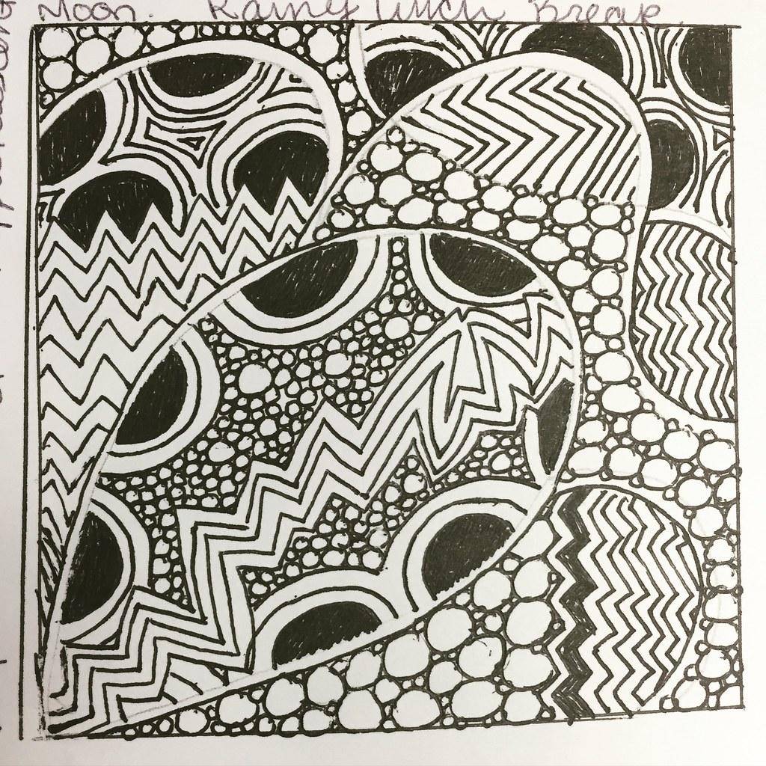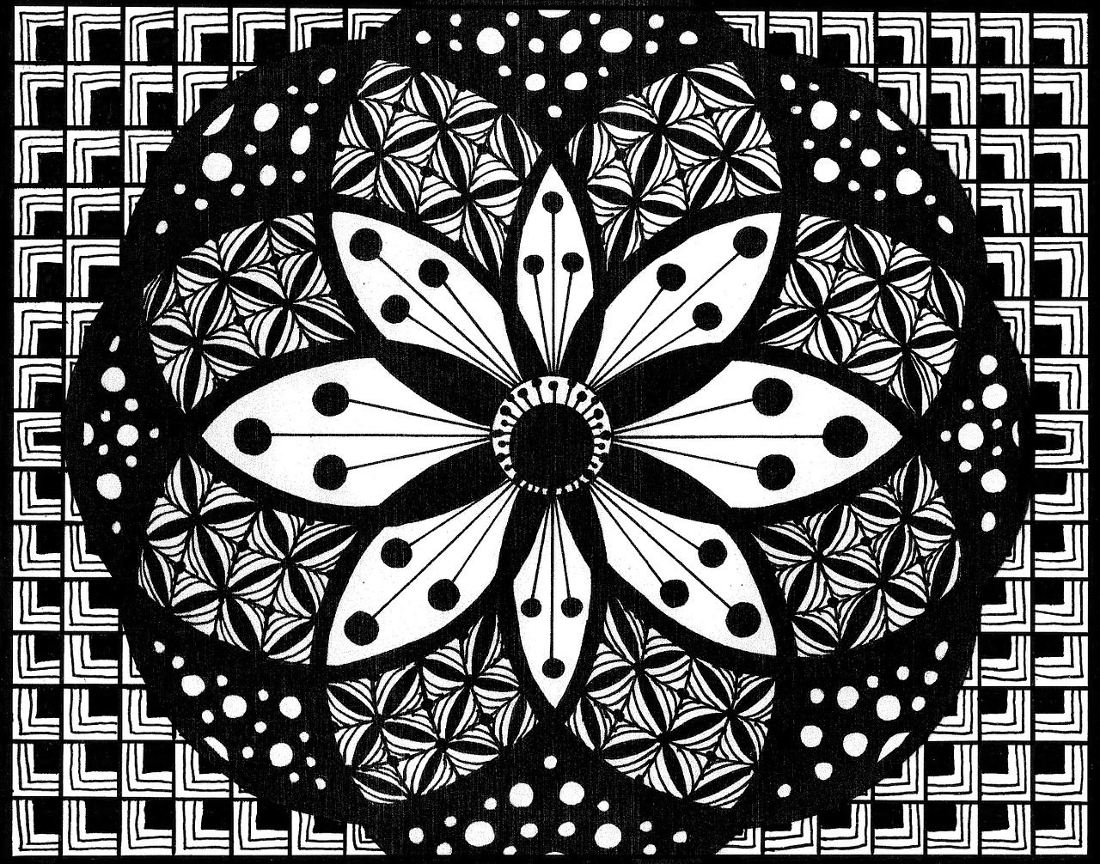

Check out these really detailed Zentangle artworks above.

For your own Zentangle artwork you may use a piece of plain white paper of any size, pencil, eraser, black marker.

***Please note that artists do not use rulers, compasses or tracers when creating Zentangles.

Creating your own Zentangle artwork.
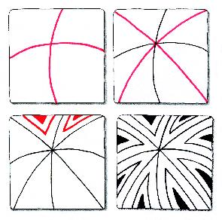
To begin your Zentangle first lightly draw a line or a series of “loose” lines on the paper. Then fill in each open space with an intricate and detailed pattern. These are known as the “tangles.” Once the drawing is finished, decide what parts you want to keep white and what parts you want to fill in with black.

Things to consider when making your Zentangle:
- Breathe. Zentangle making should be a relaxing activity.
- There are no mistakes. If you draw something you don’t like just repeat it and incorporate it into your artwork.
- Keep shapes and lines simple.
- To take it a step further, add color using marker, crayon or colored pencil.
- Be unique! Do not copy any Zentangles you see here!!!

